[ECS Linux 服务器公钥秘钥SSH登录](http://www.cnblogs.com/dunitian/p/4970813.html)

Ubuntu 14.04.1为例，设置步骤如下：

一. 生成密钥的公钥和私钥

1. # ssh-keygen -t rsa
2. Generating public/private rsa key pair.

Enter file in which to save the key (/root/.ssh/id_rsa):

Created directory '/root/.ssh'.

Enter passphrase (empty for no passphrase): #输入密码

Enter same passphrase again:                #输入密码

Your identification has been saved in /root/.ssh/id_rsa.

Your public key has been saved in /root/.ssh/id_rsa.pub.

The key fingerprint is:

              1c:37:a8:a3:65:a2:4a:89:ab:46:30:ad:54:d1:40:eb root@iZ28vo50eu5Z

二. 将生成的私钥（id_rsa）下载到本地的windows机器上，并把公钥导入到.ssh/authorized_keys 文件中去

#  cd /root/.ssh/

1. #cat id_rsa.pub > authorized_keys

三. 设置sshd  服务器服务，打开以下设置：

1. RSAAuthentication yes
2. PubkeyAuthentication yes
3. AuthorizedKeysFile      /root/.ssh/authorized_keys
4. 修改以下设置：
5. ChallengeResponseAuthentication no
6. PasswordAuthentication no
7. UsePAM no

四. 重启ssh服务

1. #service ssh  restart

五. 导入私钥到远程工具中，比如xshell。

     新建连接，点击左边用户身份验证：

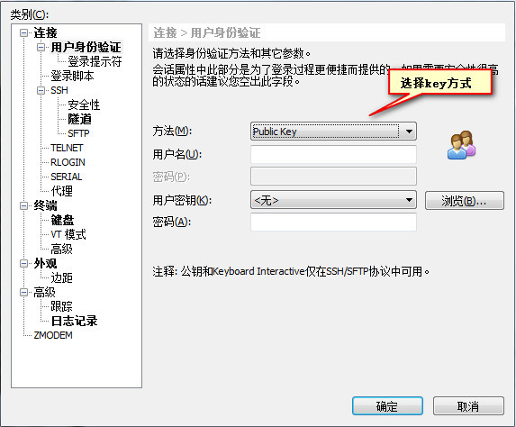

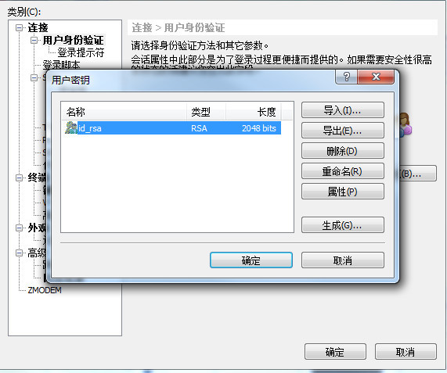

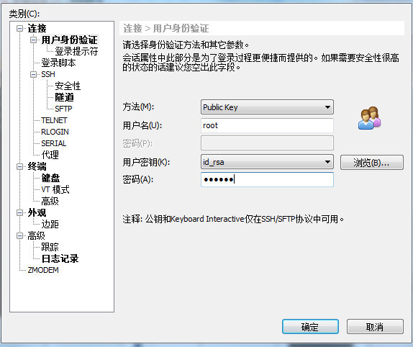

 http://help.aliyun.com/knowledge_detail/6502152.html?spm=5176.7114037.1996646101.29.mSdCu4&pos=15